**PROJECT BASED LEARNING REPORT**

**ON**

**SIMPLE SCALE COMPANY NETWORK DESING**

**AND IMPLEMENTATION**

**Submitted**

**In partial fulfilment**

**For the award of the course completeof**

**CCNA(CISCO CERTIFIED NETWORK ASSOCIATE)**



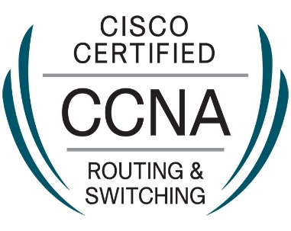

Submitted by :

NAME: Rohith A.P

MAIL ID: [rohithpalanisamy238@gmail.com](mailto:rohithpalanisamy238@gmail.com)

Phone : 7010762091

Course: CCNA

**JANUARY 2024**

**Besant technologies**

**Software training institute in thiruvanmiyur**

**CERTIFICATE**

**This is certify that Mr.Rohith A.P has complete the project based learning**

**Report successfully on the topic CCNA. Create simple network desing and**

**Implemenationby using cisco pocket tracer.**

Project Mentor :

( Mr Mohamad anaas)

CONTENTS

Abstract…………………………………………………………………………………………….. Introducation…………………………………………………………………………………….

IP Address definition ………………………………………………………………………..

Ip address class …………………………………………………………………………………

Subnetting class c ……………………………………………………………………………..

Subnetting caculation ………………………………………………………………………..

Device selection assigning vlan …………………………………………………………..

Switch configuration ………………………………………………………………………….

Confiruration wlan-wireless network …………………………………………………

Switch to rowter configuration ………………………………………………………….

Rowter configuration…………………………………………………………………………

DHCP configuration ………………………………………………………………………….

DHCP setup checking…………………………………………………………………………

Final output cisco file ……………………………………………………………………….

Conclusion ……………………………………………………………………………………….

ABSTRACTION :

**Casa study and requirements :**

Xyz company is a fast- growing company in eastern Australia With more than 2 million customers globally. The company Deals with selling and buying of food items, whitch are Basically operated from the headquarters. The company is interding to open a branch near the local village bonalbo.thus,the company requires young IT graduates to desing the network for the branch.the network is intended to operate separetly from the HQ network. Being a small network, the company has the following requirements during impleonementation;

* One router and one switch to be used (all CISCO products ).
* 3 departments ( admin/IT,finance/ HR and customer service/ resception).
* Each department is required to be in different VLANS.
* Each department is required to have a wireless network for the user.
* Host device in the network are required to obtain IPv4 address automatically.
* Devices in the departments are required to communicate with each others.

Assume the ISP gave out a base network off 192.168.1.0, you as the young network enginner who has been hired, desing and implement a network considering the abve requirement.

**TECHONOLOGIES IMPLEMENTED :**

* Create a simple network using a router and access layer switch.
* Connection network devices with correct cabling.
* Creating VLANs and assingning ports VLAN number.
* subnetting and IP addressing.
* Configuration inter-VLAN routing ( routing on a stick )
* Configuration DHCP server ( routing as the DHCP server )
* Configuration WLAN or wireless networking (cisco access point).
* Host devices configuration.
* Test and verifying network communication

**KEY WORDS**

* ISP – internet sevices protocol
* DHCP – Dynamic
* Host configuration
* Protocol
* LAN- local area network
* HR-
* Human
* Resources
* Pc-
* Personal
* Computer
* URL-
* Uniform
* Resources
* Locatar NAT-
* Network
* Address
* Translation IP
* -internet
* Protocol
* Kbps-
* Kilobite per
* Second
* Mbps
* Megabits
* Per second
* Gbps
* Gigabits
* Second AP
* Access point
* VLAN- virtual
* Local area
* Network
* DNS- domain
* Name system
* SSH- secure shell protocol
* OSPF- open shortest path first
* PAT- port address translation
* STP- spanning tree protocal
  1. **department and users**

computer has 3 floors,3 department ,and 6 other users

|  |  |
| --- | --- |
| **Department** | users |
| Ground floor |  |
| Reception | Users – 2 |
| 1st floor |  |
| Finance and account & HR department | Users – 2 |
| 2nd floor |  |
|  |  |

* 1. **IP Address and subnetting :**

**Definition of IP address : An IP address** is an 32 bit number that logically defines a host. Ip address assigned to a LAN card or a device interface can change base on network admin’s requirement.

**Definition of subnet mask :** subnet mask is a 32 bits value that defines which portion of an IP address is network and which portion is host

Definition of subnetting and its requirement: subnetting is extending the network portion and reducing the host. Advantage of subnetting is that helps a network admin to efficiently use the network Ips.

IP address were divided into five different categories called **classes**. These divides IP classes are class A, class B, class C, class D, class E. out of these, classes A,B, and C are most important. Each address class defines a different number of bit for its **network prefix**

**(network address )** and host number (host address) the starting address bit decide from which class address an belongs.

**NETWORK ADDRESS HOST ADDRESS**

**←---------------------------------------→ ←----------------------------------→**

|  |
| --- |
| **192 . 168 . 1 . 0** |

**Network address :** The network address specifies the unique number which is assigned to your network. In the above figure, the network address taken two bytes of IP address.

**Host Address** : A host address is a specific address number assigned to each host machine. With the help of the host address, each machine is indentified in your network. The network address will be the same for each host in a network, but they must vary in host address.

**Address format IPv4**:

The address format of IPv4 is represented into 4-octets (32-bits), which a divided into three different classes, namely class A, class B ,and class c.

4 OCTETS

**←------------------------→**

192 . 168 . 1 . 0

The above diagram shows the address format of IPsv4. An IPsv4 is an 32 bits decimal address. It contains four octets or fields separated by ‘DOT,’ and each field is 8 bits in size. The number that each filed contains should be in the range of 0-255.

**CLASS A** address uses only higher order octet (byte) to idenitify the network prefix, and remaining three octet or filed separated by ‘DOT,’ and each field is 8 bit in size. The number that each field contains should be in the range of 0-255.

**CLASS A :** address user only first higher order octet (bytes) to identify the network prefix, and remaining three octets (bytes) are used to define the individual host address. The class address range between 0.0.0.0 to 127.255.255.255. the first bit of the first bit of the first octet is always set to 0 (zero), and next 7 bits determine network address, and the remaining 24 bits determine host address. So the first octet ranges from 0 to 127 (00000000 to 11111111).

**CLASS B :** addresses use the intial two octets (two bytes) to identity the network prefix, and the remaining two octets (two bytes) defined host address. The class B address are range between 128.0.0.0 to 191.255.255.255. the first two bits of the first higher octet is always set to 10 (one and zero bit), and next 14 bits determine the network address and remaining 16bits determine the host address. So the first octet range from 0 to 127 (10000000 to 10111111).

**CLASS C :**  addresses use the first three octets (three bytes) to identify the network prefix, and the remaining last octet (one byte) defined the host address. The class c address range between 192.0.0.0 to 223.255.255.255. the first three bit of the host address. Its first octet range from 192.223 (11000000 to 1101111).

**CLASS D: IP** address is reserved for multicast addresses. Its first four bits of the first octet are always set to 1110, and the remining bits determine the host address in any IP address. The first highest octet bits are always set to 1110, and the remaning bits specify the host address. The class D address range between 224.0.0.0 To 239.255.255.255. In multicasting, data is not assigned to any particular host machine, so it is not required to find the host address from the Ips address from the IP address ,and also there is no subnet mask present in class D

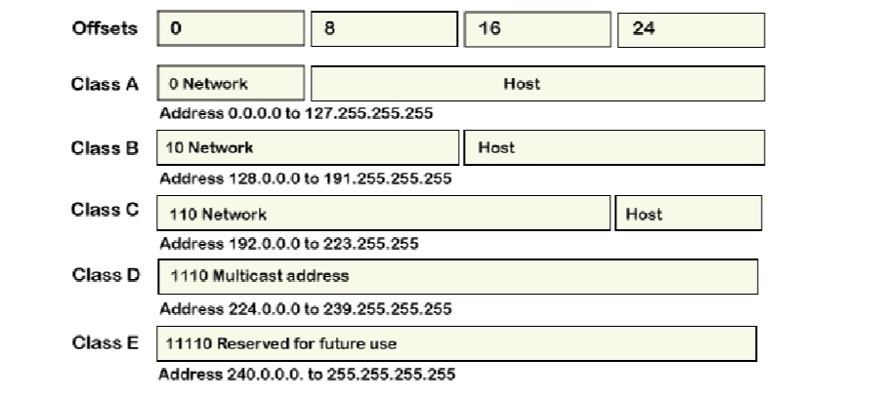

In every IP address class, all host -number bits are specified by a power of 2 that indicates the total numbers of the host’s address that can create for a particular network address. Class A address can contain the maximum number of 224 (16,777,216) host numbers. ClassB address contain the maximum number of 216(65,536) host numbers. And class C contain a maximum number of 28(256) host numbers.

The fillowing IP addressing scheme has been implemented for better connectivity throughout

Oranganization. **Base network: 192.168.1.0**

**Required No.of subnets: 3**

**No.of sbnet calculate:2^n , 2^n=3, n=2**

**2.2 subnetting class c – 192.168.1.0/26**

With mask /26, subnet mask will be 255.255.255.192. binary valve of last octet is 11000000. Using this let’s proceed further.

* Number of subnets( for/25mask) = 2N

N= 2, because now 2 bit are borrow from host portion, therefore 22 =4

Number of subnets (for/25 mask)=4

* Number of host per subnet = (2H) -2

H is 6, because 6 zeros are left in host portion, therefore 26 -2

Host per subnet= (64-2) =62.

* Block size of each subnet = 256-192 = 64

For /26 mask, we will get subnet, each with 62 hosts, each subnet has block size of 64.

* 1st subnet = 192.168. 1. 0/26
* 2rd subnet = 192.168.1.6/26
* 3rd subnet = 192.168.1.128/26
* 4rd subnet = 192.168.1.192/26
* For 1st subnet, 1st valve IP is 192.168.1.1/26, last vaild ip is 192.168.1.62, and brondcast address is 192.168.1.63/26
* For 2nd subnet, 1st valve IP is 192.168.1.65/26, last vaild IP is 192.168.1,126/26, and broadcase address is 192.168.1.127/26
* For 3nd subnet, 1st valve IP is 192.168.1.128/26, last vaild ip is 192.168.1.198/26, and boradcase address is 192.168.1.191/26
* For 4th subnet 1st vail dip is 192.168.1.193/26, last vaild IP is 192.168.1.254/26,and broadcase address is 192.168.1.255/26

We subtracted 2 from host portion of each subnet because second last IP of each subnet is (for example .127 and .255) is broadcase address and .0 and .128 and network address

**Subnet mask : 255.255.255.192**

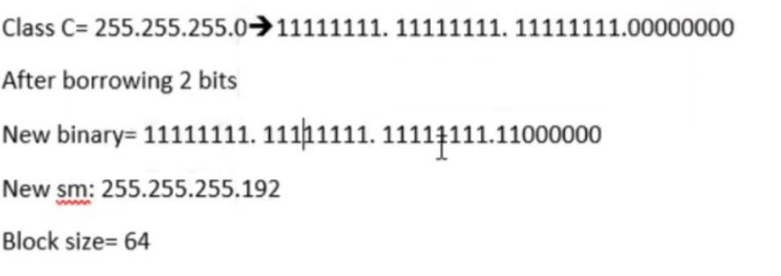

**2.1 assingning VLANs**

Each department has a uniqe VLAN to diving the department/sub department and to reduce traffic on each link on the network. For the easy reference we assigned the same VLAN ID to the DHCP pool of every department.

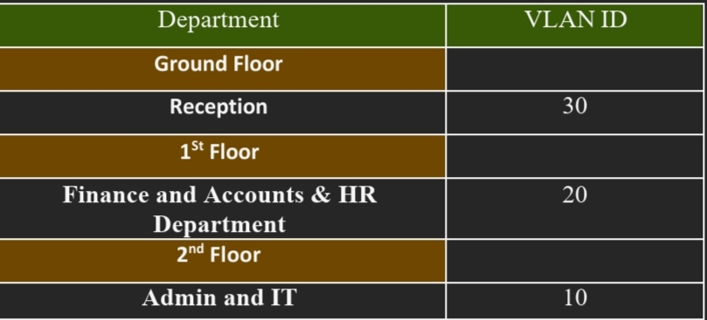

**PROCEDURES:**

1. Open cisco packet tracer and select the router and switches.
2. Router selection: 2911 core-1 1no.
3. Switch 2960-24TT 1nos, and access point-AP.
4. Pc, printer, laptop for each department.
5. Select the cable connectivity and connect all devices as per network diagram.

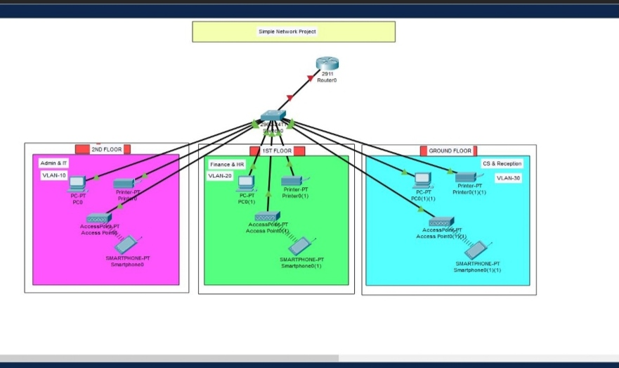

**SWITCH CONFIGURATION:**

Switch>

Switch>enable

Switch#config t

Switch(config)#enable password cisco

Switch(config)#vlan 10

Switch(config-vlan)#name admin

Switch(config-vlan)#exit

Switch(config)#vlan 20

Switch(config-vlan)#name finance

Switch(config-vlan)#exit

Switch(config)#vlan 30

Switch(config-vlan)#name reception

Switch(config-vlan)#exit

Switch(config)# do wr

Switch(config)#int range fa0/2-4

Switch(config-if-range)#switchport mode access

Switch(config-if-range)#switchport access vlan 10

Switch(config-if-range)#exit

Switch(config)#do wr

Switch(config)#int range fa0/5-7

Switch(config-if-range)#switchport mode access

Switch(config-if-range)#switchport access vlan 20

Switch(config-if-range)#exit

Switch(config)#do wr

Switch(config)#int range fa0/8-10

Switch(config- if-range)#switchport mode access

Switch(config-if-range)#switchport access vlan 30

Switch(config-if-range)#exit

Switch(config)#do wr

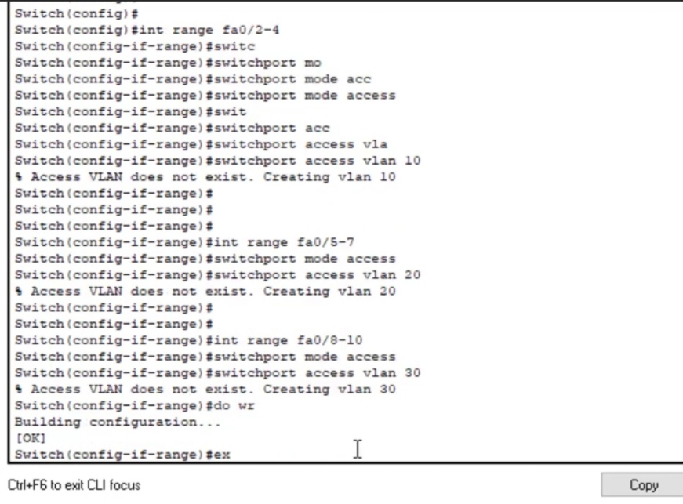

**Confinguring WLAN-wire less networking using cisco access point:**

1. Admin-wifi
2. Finance-wifi
3. Reception-wifi and set password tp each access point.

Select the access point and go to the config tab and set SSID and password. As shows the belong figure.

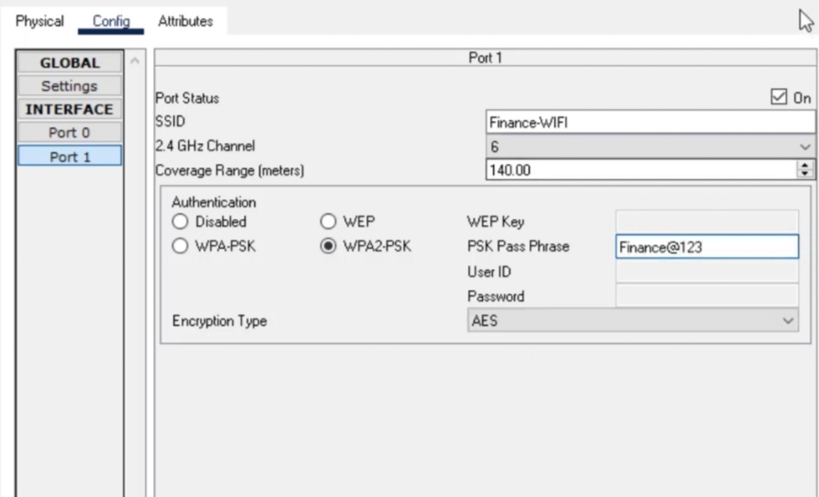

**Switch to router config:**

Switch(config)#int fa0/1

Switch(config-if)#switchport mode trunk

Switch(config-if)#do wr

Switch(config-if)#exit

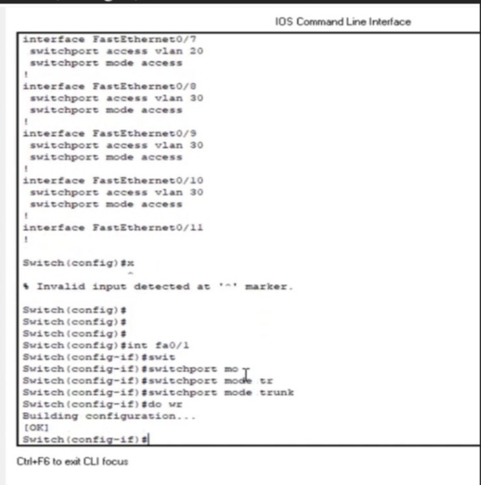

**Router config and sub-interface configure**:

Router>enable

Router#config t

Router(config)#enable password cisco

Router(config)int gig0/0

Router(config-if)#no shutdown

Router(config)#do wr

Router(config)#exit

Router(config)#int gig0/0.10

Router(config-subif)#encapsulation dot1Q 10

Router(config-subif)ip address 192.168.1.1 255.255.255.192

Exit

Router(config)#int gig0/0.20

Router(config-subif)#encapsulation dot1Q 20

Router(config-subif)#ip address 192.168.1.129 255.255.255,192

Router(config-subif)#exit

Router(config)#int gig0/0.30

Router(config-subif)#iencapulation dot1Q 30

Router(config-subif)ip address 193.168.1.129 255.255.255.192

Router(config-subif)#do wr

Router(config-subif)#exit

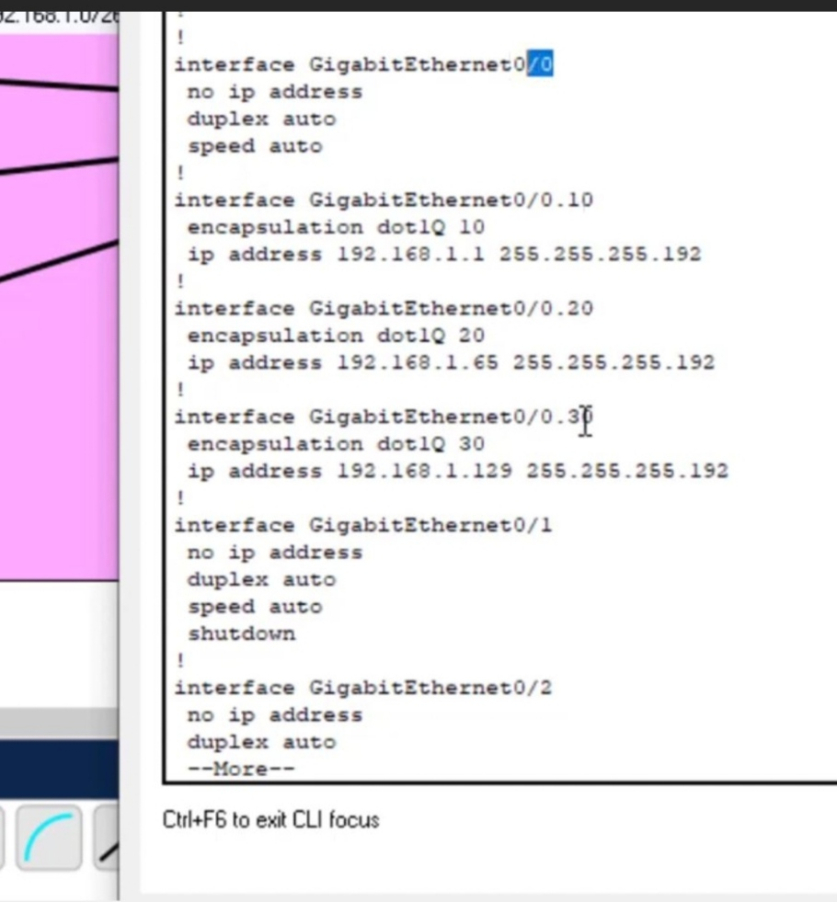

**DHCP SERVICE**:

Router(config)#service dhcp

Router(config)#ip dhcp pool admit-pool

Router(dhcp-config)#network 192.168.1.0 255.255.255.192

Router(dhcp-config)#defauld-router 192.168.1.1

Router(dhcp-config)dns-server 192.1668.1.1

Router(dhcp-config)#domain-name admin.com

Router(config)#exit

Router(config)#ip dhcp pool finance-pool

Router(dhcp-config)#network 192.168.1.64 255.255.255.192

Router(dhcp-config)#defauld-router 192.168.1.65

Router(dhcp-config)#dns-server 192.168.1.65

Router(dhcp-config)#domian-name reception.com

Router(dhcp-config)#exit

Router(dhcp-config)#do wr

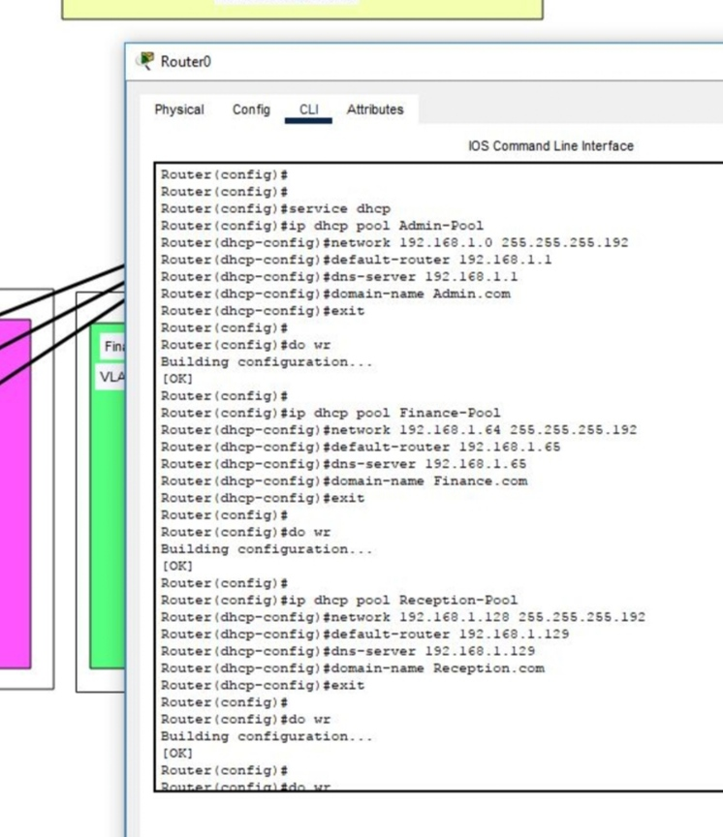

Enable the DHCP on all department pc and printers.

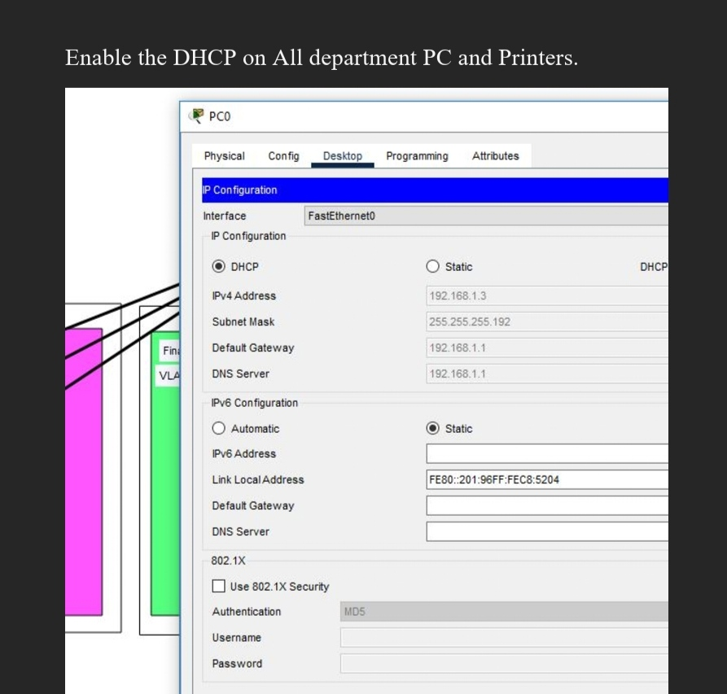

Check all networking status by ping command:

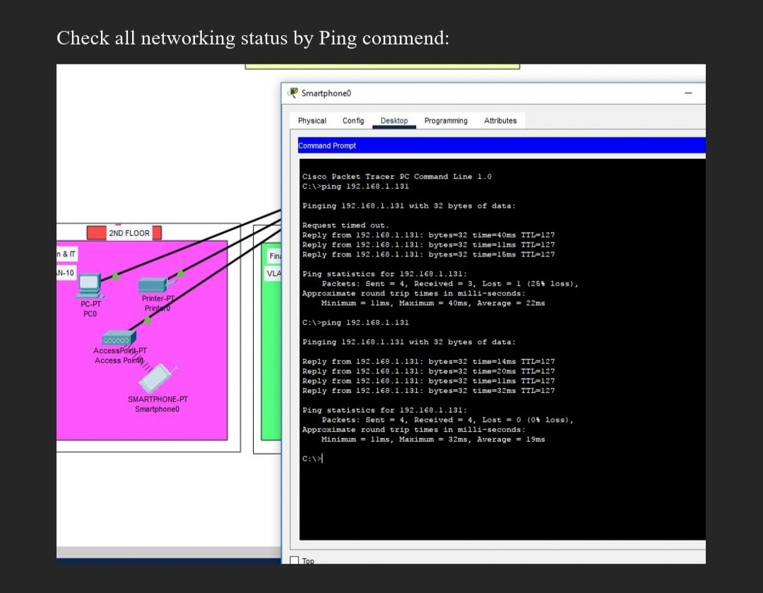

**FINAL OUTPUT:**

**NETWORK TOPOLOGY CREATED:**

The network topology below satifies the user requirement above and everything is verified. Tested and working fine.

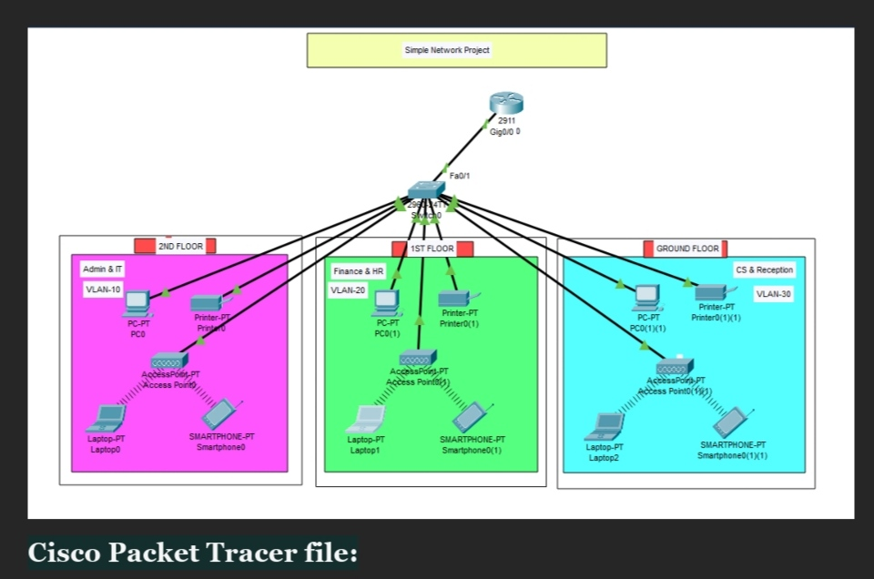

**CONCLUSION:**

**T**his project presents the theoretical and practical analysis of network diagram,creating VLANs and assigning ports VLAN number. Subnetting and IP addressing.configuring inter – VLAN routing DHCP server

( Router as the DHCP server). WLAN or wireless network (cisco access point).